Tasks
1.
Create a comparison table listing at least 4 key differences between RADIUS and TACACS+ features, focusing on protocol type, encryption, ports used, and command authorization.
>
Feature | RADIUS | TACACS+
Protocol Type | Standard-based (open standard, RFC compliant). | Cisco proprietary protocol (now an open standard but primarily used on Cisco).
Layer 4 Protocol & Ports | Uses UDP (Ports 1812 for Authentication/Authorization, 1813 for Accounting). | Uses TCP (Port 49).
Encryption | Encrypts only the password field in the packet. The username, attributes, and data are sent in plaintext. | Encrypts the entire packet body. Only a standard TACACS+ header remains unencrypted.
Command Authorization | Does not support per-command authorization. It handles Authentication and Authorization together. | Fully supports granular, per-command authorization (checks if an admin can run a specific command like configure terminal).

2.
Draw a simple flowchart or sequence diagram that illustrates the RADIUS authentication process for a user trying to log in to a Wi-Fi network (like at a coffee shop or college campus).
>

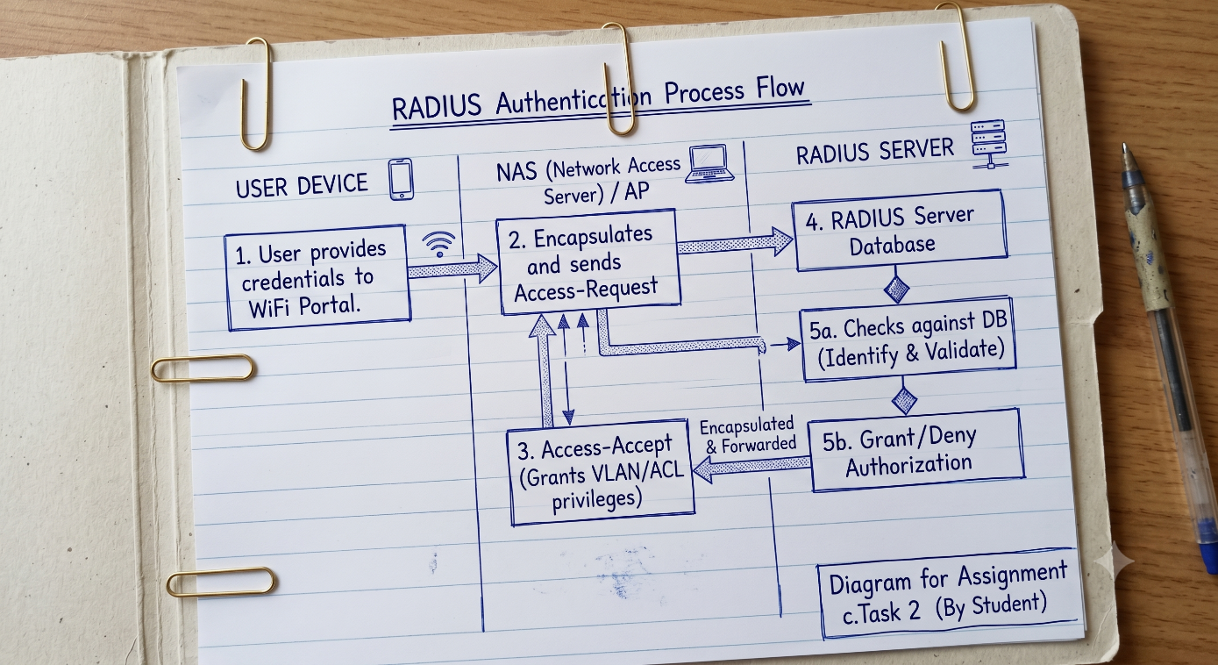

3.
Describe a real-world scenario from any app you use (such as Zomato, Paytm, or IRCTC) where TACACS+ would be more suitable than RADIUS for managing admin access, and explain why.
>
Scenario
Consider a massive infrastructure application like IRCTC (Indian Railway Catering and Tourism Corporation). Thousands of network backend switches and routers handle payments and ticket bookings.
Why TACACS+ is more suitable than RADIUS for Admin Access
- Granular Command Authorization: In a high-security environment like IRCTC, network engineers have different authorization levels. A junior engineer should only be allowed to run monitoring commands (like show running-config), whereas a senior architect should be allowed to make configuration modifications. TACACS+ checks every single typed command against the central server before executing it. RADIUS cannot do this.
- Separation of AAA: TACACS+ splits Authentication, Authorization, and Accounting into distinct functions. This allows IRCTC to authenticate via an active directory server but use a separate system to authorize specific commands, ensuring robust control over administrative operations.

4.
List two advantages and two disadvantages of using RADIUS for network authentication in a public hotspot (like those found in malls or airports).
>
Advantages
- Stateless and Fast Performance (UDP): Public hotspots (like malls or airports) handle thousands of transient users. RADIUS uses UDP, which has less overhead than TCP, making connection establishment faster and lighter on server resources.
- Massive Multivendor Interoperability: Public hotspot equipment is often made up of diverse network brands (Ubiquiti, Aruba, Cisco). Because RADIUS is a universally supported open standard, it works flawlessly across all hardware vendors.
Disadvantages
- Security Vulnerability (Plaintext Data): Since RADIUS only encrypts the password field, an attacker sniffing packets on the local area network can see the usernames and MAC addresses of connecting patrons.
- Connection Reliability Issues: Because UDP does not guarantee packet delivery like TCP does, the NAS has to handle timeouts and retransmissions manually if the server experiences slight packet drops, sometimes causing login delays for users.

5.
Use ChatGPT or another AI tool to generate a sample TACACS+ configuration for a Cisco router, then review the output and highlight any commands you would modify for a college lab setup.<br><br><em><strong>Hint:</strong> Ask the AI tool for 'basic TACACS+ configuration for Cisco router' and check for lines like 'tacacs-server host' and 'aaa new-model'.</em>
>
Standard TACACS+ Configuration for Cisco Router
! Enable AAA security services
aaa new-model

! Configure TACACS+ Server Group and Server Location
aaa group server tacacs+ TAC-GROUP
server-private 192.168.1.50 key MySecretServerKey

! Configure AAA Authentication for login using the TACACS group, falling back to local credentials
aaa authentication login default group tacacs+ local

! Configure AAA Authorization for commands
aaa authorization exec default group tacacs+ local
aaa authorization commands 15 default group tacacs+ local

! Map the Server Group to the Server Details
tacacs server MyTacacsServer
address ipv4 192.168.1.50
key MySecretServerKey

Necessary Modifications for a College Lab Setup
- Modify Server IP (192.168.1.50): Change this address to point directly to the local internal college lab server (e.g., 10.20.30.15).
- Modify Shared Key (MySecretServerKey): Replace this placeholder with the unique cryptographic password explicitly assigned to the lab network switches (e.g., LabSecurePass2026).
- Adjust Command Levels: For a college lab, you might remove aaa authorization commands 15 or limit it so students do not accidentally lock themselves out of executive configurations when testing configurations on real equipment.

